ABE 55700

Homework 2 | Sterilization and Finite Difference

Nathan LeRoy

Sept. 20th, 2018

**Problem 5.2-3**

We have a tank that is being continuously stirred at a relatively high RPM. With this information, it is safe to make the assumption that the inside temperature of our tank is uniform. Thermodynamically, this indicates that our convective heat transfer resistance inside the tank is negligible or zero. In addition, we can assume that the walls are thin enough such that the conductivity resistance through the walls is also negligible. Thus, our temperature profile may look something like this:

Ts = 377.6 K

Tw = f(t)

We are given some information on our tank and the relevant thermodynamics of the system:

|  |  |
| --- | --- |
| ***Parameter*** | ***Value*** |
| Volume, V [m3] | 0.0283 |
| Initial Water Temp, T0, [K] | 288.8 |
| Steam Bath Temp, Ts, [K] | 377.6 |
| Heat Transfer Coeff, U, [W/m2-K] | 1136 |
| Surface Area, A, [m2] | 0.372 |
| Desired Water Temp, Tw(t), [K] | 338.7 |

Heat transfer is governed by the following equation:

$$\dot{q} \left[J/s\right]=UA\left(T_{s}-T_{w}\left(t\right)\right)$$

We can introduce some basic thermodynamic constants for our system to obtain an equation that characterizes instantaneous temperature changes in our system:

$$\frac{\dot{q}}{c_{p}ρV} = \frac{dT_{w}}{dt} = \frac{UA}{c_{p}ρV}\left(T_{s} - T_{w}\right)$$

This equation can be integrated with the given initial conditions to achieve the following:

$$ln\left(\frac{T_{s} - T_{w}}{T_{s} - T_{0}}\right) = -\frac{UA}{c_{p}ρV}∙t$$

Using the specific heat of water, its density, and the given conditions, we can solve for the time required to reach our desired temperature. The calculations were done in excel and the calculated time was found to be 232.15 seconds.

**Problem 5.4 – 5**

Unsteady state heat transfer in a slab is untrivial and solving the associated differential equations is difficult since there are partial differentials involved. Numerical methods are overwhelmingly the method of choice for solving these equations and obtaining transient analysis of systems. For partial differential equations, we use a method known as the finite difference method. Beginning with the heat transfer equation:

$$\frac{∂T}{∂t} = α\frac{∂^{2}T}{{∂x}^{2}}$$

We can use the definition of derivatives to create an equation to estimate temperature changes over the course of a space and time:

$$Conduction inside: T_{t + ∆t}^{n} = \frac{1}{M}\left[T_{t}^{n + 1}+\left(M-2\right)T_{t}^{n}+T_{t}^{n-1}\right]$$

$$Convection into air: T_{t + ∆t}^{1} = \frac{1}{M}\left[2NT_{t}^{0} + (M-(2N+2)T_{t}^{1} + 2T_{2}^{t}\right]$$

$$Insulated Boundary: T_{t + ∆t}^{f} = \frac{1}{M}\left[\left(M-2\right)T_{t}^{f}+2T_{t}^{f - 1}\right]$$

Where M is $\frac{{∆x}^{2}}{α∆t}$. α is the thermal diffusivity of our system. N is $\frac{h∆x}{k}$. We can “slice” the meat slab into sections and analyze the temperature gradient across each slice.

The system parameters are given as the following:

|  |  |
| --- | --- |
| *Thickness, L (mm)* | 45.7 |
| *Thickness, L (m)* | 0.0457 |
| *To, meat, (C)* | 37.78 |
| *To, meat, (K)* | 310.78 |
| *Tair, (C)* | -1.11 |
| *Tair, (K)* | 271.89 |
| *h, conv. (W/m^2-K)* | 38 |
| *k, cond. (W/m-k)* | 0.498 |
| *diffusivity, α, m^2/h* | 0.000464 |
| *diffusivity, α, m^2/s* | 1.28889E-07 |
| *num slices* | 5 |
| *M* | 4 |
| *N* | 0.697429719 |
| *Δx* | 0.00914 |
| *Δt* | 162.0380172 |

Employing the finite difference method and the appropriate equations in the appropriate regions in excel, we obtain a profile that looks like this:

**Figure 1.** The above graph gives the temperature profile inside our slab of meat for various times. Initially, at time = 0, the temperature is a uniform 37.7 deg C. Over time, the temperature decreases inside our slab. This occurs much more rapidly at the face of the slab being blasted with chilled air. The steady state profile would follow a linear profile.

The exact temperature profile after 0.27 hours is:

|  |  |
| --- | --- |
| **Depth, mm [node]** | **Temperature, °C** |
| 0 (n = 1) | 16.71 |
| 9.14 (n = 2) | 27.57 |
| 18.28 (n = 3) | 34.00 |
| 27.42 (n = 4) | 36.78 |
| 36.56 (n = 5) | 37.61 |
| 45.7 (n = 6) | 37.75 |

**Problem 9.12 – 5**

In sterilization studies, the Fo value of a process is the time at 250°F that will produce the same degree of sterilization as the given process at its temperature T. More precisely, it is the equivalent-minutes of exposure to 250°C. The desired F0 of our process is 2.60 min. This indicates that over the course of our process we want an equivalent exposure of 2.60 minutes at 250°C. Typically, for constant temperature systems and processes, we can use the following equation to calculate the F0 value:

The z-value is a system-dependent constant that is usually obtained from empirical studies. For a non-constant temperature system, our equation becomes a little more complex by summing the individual pieces of our process and their subsequent F0 values:

$$F_{0} = \sum_{i = 1}^{n}{\left(t_{i+1} - t_{i}\right){10}^{\frac{T_{i}-250}{z}}}$$

Using the following data…

|  |  |  |
| --- | --- | --- |
| **Time (min)** | **T (°F)** | **T (°C)** |
| 0 | 110 | 43.33333 |
| 20 | 165 | 73.88889 |
| 40 | 205 | 96.11111 |
| 60 | 228 | 108.8889 |
| 80 | 232 | 111.1111 |
| 90 | 225 | 107.2222 |
| 100 | 160 | 71.11111 |

With z-values of 18°F and 10°C. The calculations were completed in excel, and the F0 values for our Celsius and Fahrenheit measurements were 2.67 and 2.74 minutes respectively.

**Problem 9.12 – 6**

Sterility is incredibly important for food processes. Safety is the number one priority when it comes to the consumer market and understanding how this occurs and mathematically characterizing the process is vital. It is known that sterilization occurs as a first-order process:

$$\frac{dN}{dt} = -kN$$

Where k is often a function of the system parameters, namely temperature. In this problem, we are given this kinetic constant as:

$$k = 7.94 × {10}^{38}e^{-\left(68.7×{10}^{3}\right)/1.987T}$$

We are given Temperature versus time data in a table. We can calculate the kinetic constant at the various temperatures and plot this data over time (Fig. 2).

**Figure 2.** k(T) plotted over time. One can see that it increases in the middle of the process. This is a direct result of the increase in temperature at that time.

We can characterize the sterilization mathematically as the following equation(s):

$$∇ = ln\frac{N_{0}}{N} = \int_{0}^{t}{k dt}$$

Obliviously, we do not have continuous data on the kinetic constant over time, so we can approximate the integral with the following midpoint Riemann sum formula:

$$\int_{0}^{t}{k dt} ≈ \sum_{i = 0}^{5}{\frac{{k\left(T\right)}_{i + 1} + {k\left(T\right)}_{i}}{2} ∆t}$$

When conducting these calculations in excel, we obtain a value, $∇$ = 67.28. This allows us to calculate the final sterility level with the following equation:

$$N = \frac{N_{0}}{e^{∇}}$$

Again, with excel, we can obtain a value of N = 8.17e-19.

**Problem 9.12 – 7**

As stated before, the Fo value of a process is the time at 250°F that will produce the same degree of sterilization as the given process at its temperature T. More precisely, it is the equivalent-minutes of exposure to 250°C. However, in this case we are interested in exposure to the temperature 65.2°C. We know that an Equivalent F0 can be calculated with the following equation:

$$F_{0} = t{∙10}^{\frac{T - 65.6°C}{5°C}}$$

Rearranging, we can calculate the needed pasteurization time:

$$t = \frac{F_{0}}{{10}^{\frac{T - 65.6°C}{5°C}}}$$

Using the given values and constants, we can then calculate that the needed pasteurization time is 32.67 minutes. The calculations are relatively trivial and an excel sheet was not needed to conduct this.

**Derivation of Equation 5.4 – 23**

In

Out

We start with ol’ faithful: $Accumulation = In - Out + Generation - Consumption$

We are examining the heat transfer right at the boundary of our cylindrical system such that there is convection at the surface, and conduction underneath. Our starting equation becomes:

$$ρc_{p}V\frac{∂T}{∂t} = hA_{conv}\frac{∂T}{∂r}|_{r + dr}^{} - kA_{cond}\frac{∂T}{∂r}|_{r}^{}$$

Convection at surface

Conduction under surface

Dividing both sides by $ρc_{p}$ lets us define some constants, namely, thermal diffusivity, α, and a convective thermal diffusivity, β:

$$α = \frac{k}{ρc_{p}}, β = \frac{h}{ρc_{p}}$$

Introducing the volume of our cylinder, and the two areas:

$$V=π\left({\left(r+∆r\right)}^{2} - r^{2}\right),{ A}_{conv}=2π\left(r+∆r\right),{ A}_{cond}=2πr$$

We can simplify the equation and cancel out many terms related to volume to obtain the following equation:

$$\frac{∂T}{∂t}=\frac{β}{r∆r}\left(r+∆r\right)\frac{∂T}{∂r}|_{r + dr}^{}-\frac{α}{∆r}\frac{∂T}{∂r}|_{r}^{}$$

From here, we can use the definition of derivatives to obtain a numerically solvable equation too estimate the temperature profile within a cylindrical system: $$\frac{∂T}{∂t} = \frac{T_{t + ∆t}^{n} - T_{t}^{n}}{∆t}, \frac{∂T}{∂r}|_{r + dr}^{} = \frac{T_{t}^{0} - T_{t}^{1}}{∆r}, \frac{∂T}{∂r}|_{r}^{} = \frac{T_{t}^{1} - T_{t}^{2}}{∆r}$$

$$\frac{T_{t + ∆t}^{n} - T_{t}^{n}}{∆t} =\frac{β}{r∆r}\left(r+∆r\right)\frac{T_{t}^{0} - T_{t}^{1}}{∆r}-\frac{α}{∆r}\frac{T_{t}^{1} - T_{t}^{2}}{∆r}$$

Defining the two following constants:

$$M = \frac{α∆t}{{∆r}^{2}}, N = \frac{β∆t}{{∆r}^{2}}$$

We can then get the following equation which can be programmed to obtain our temperature profile:

$$T_{t + ∆t}^{n}=N\left(r+∆r\right)T_{t}^{0}-\left(N\left(r+∆r\right)+M+1\right)T_{t}^{1}+MT_{t}^{2}$$

**Excel Sheets**

Problem 5.2 – 3

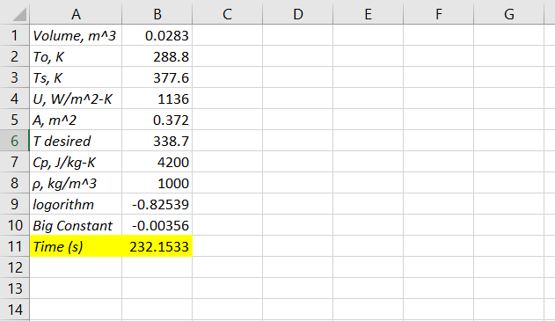

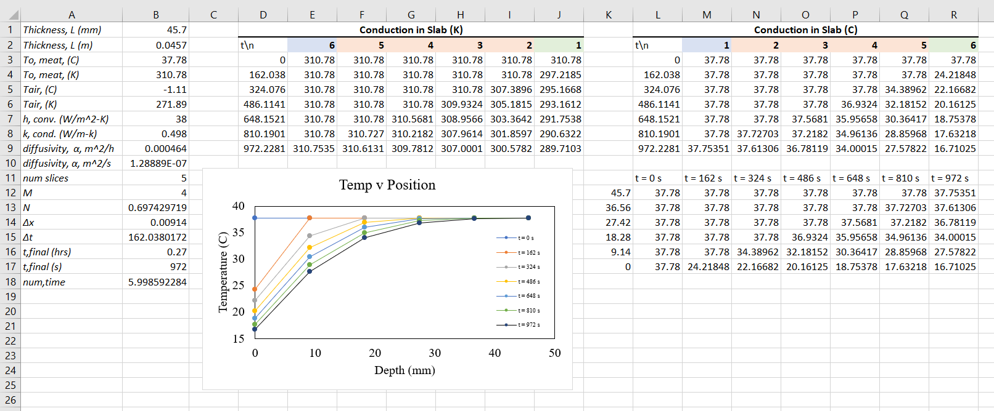Problem 5.4 – 5

Problem 9.12 – 5

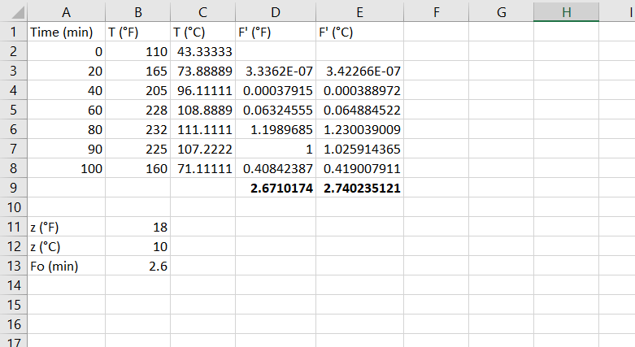

9.12 – 6

